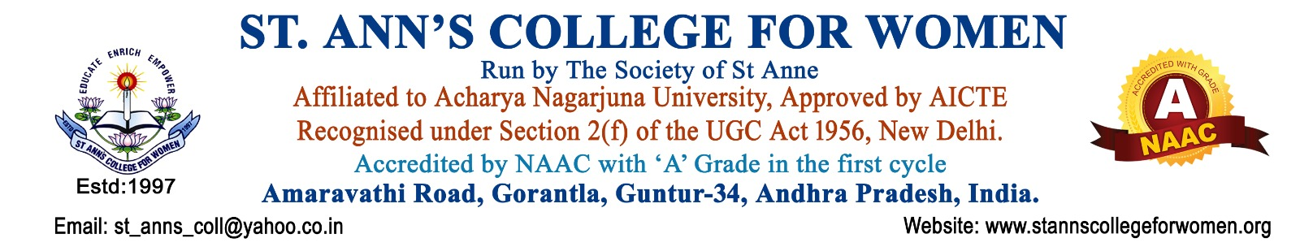

BCA Honours -Computer Applications
Empowering Students with Digital Innovation
The BCA Honours programme at St. Ann’s College for Women equips students with strong technical knowledge, programming skills, and practical exposure in emerging digital technologies. The programme prepares students for successful careers in Software Development, Data Analytics, Cyber Security, Web Technologies, and IT Services.
Note: St. Ann’s College for Women presently offers the BCA Honours -Computer Applications programme as a Three-Year Degree Programme in accordance with the Acharya Nagarjuna university and government guidelines.
Programme Highlights
- Industry-oriented curriculum
- Practical programming & software labs
- Training in Python, Java, PHP & MERN Stack
- Web & Mobile Application Development
- Exposure to Data Analytics & Cyber Security
- Cloud Computing & Modern IT Technologies
- Internship opportunities & Placement Assistance
- Career-focused skill development
Key Courses Offered
- Programming in C & Data Structures
- Database Management System
- OOPS through JAVA
- Python Programming
- Software Engineering
- Data Mining
- Computer Networks
- Web Technologies
- PHP & MySQL
- Mobile Application Development
- MERN Stack
- Cyber Security & Digital Forensics
Minor Course – Digital Marketing
- Fundamentals of Digital Marketing
- Social Media Marketing
- Affiliate Marketing
- Search Engine Optimisation (SEO)
- E-Mail Marketing
- Mobile Marketing
Career Opportunities
Students can build careers in:
- Software Development
- Web & App Development
- Data Analytics
- Cyber Security
- Cloud Computing
- Networking & System Administration
- Software Testing & IT Support
Career Roles
- Software Developer
- Web Developer
- System Engineer
- Security Analyst
- Software Tester
- App Developer
- System Administrator
Higher Education Opportunities
- MCA
- M.Sc. (IT / Computer Science)
- MBA (IT Management)
- Professional IT Certifications
- Cloud & Cyber Security Certifications
Why Choose St. Ann’s College for Women?
- Experienced and supportive faculty
- Modern computer laboratories
- Practical and project-based learning
- Internship and Placement Assistance
- Career guidance and skill development
- Holistic education with discipline and values
Eligibility
Pass in Intermediate / 10+2 or equivalent examination.
Contact Us
St. Ann’s College for Women
Gorantla, Guntur – 522 034
📞 0863-2236470
📱 73821 04655, 85006 56134
🌐 www.stannscollegeforwomen.ac.in
Admissions Open 2026–27
Build Your Future in Software, Data Analytics & Digital Technologies with BCA Honours at St. Ann’s College for Women.

